**Two cheers amid the fears**

**好消息，但有点坏**

(英文部分选自经济学人20220813财经版块)

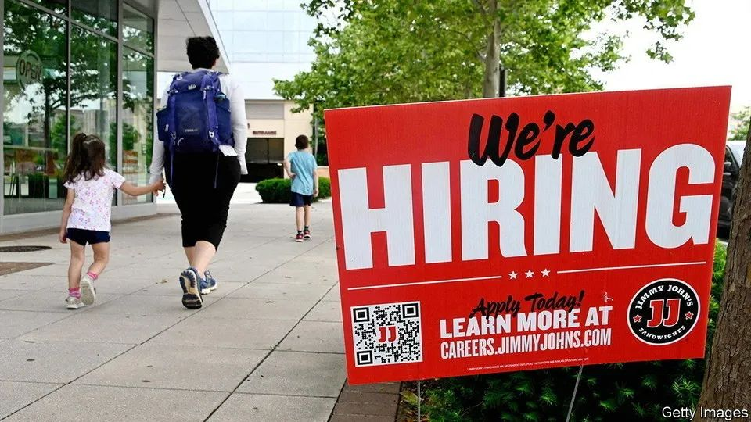

America’s economy

美国经济

**Two cheers amid the fears**

**好消息，但有点坏**

**For a change, a downside inflation surprise and an upside jobs surprise**

**万万没想到，通胀意外下降而就业意外上升**

What a difference **a couple of** data points make. Much of the recent talk about America’s economy had focused on the possibility of stagflation, as GDP shrank and prices soared. Suddenly, though, things look rosier. First, on August 5th, statisticians reported that 530,000 jobs were created in the previous month—more than twice as many as expected. Then, on August 10th, they reported that consumer prices in July were the same as in June—the first absence of month-on-month inflation since early 2020. Could the doomsayers be wrong, and America really be about to enjoy both an economic boom and price stability?

几个数据点竟会产生如此大的影响。近来，随着国内生产总值萎缩和物价飙升，关于美国经济的讨论大多都集中在滞胀发生的可能性上。但是忽然之间，形势似乎乐观了起来。首先是8月5日，统计人员报告上月新增非农就业人数530000人，是预期的两倍有余。然后是8月10日，他们报告7月CPI与 6月份持平——这是自2020年年初以来首次出现月度环比零增长。难道那些经济唱衰者错了吗？美国真的可以同时实现经济繁荣和价格稳定吗？

Not so fast. It is foolish to **rush to any conclusion** based on a week’s worth of data, especially **amid the lingering covid-19 pandemic and war in Ukraine**. Previous bursts of optimism have proved, unlike inflation, to be transitory. Moreover, a closer look at both reports gives as much reason for consternation as for celebration.

不要这么快下结论。根据这一周出炉的数据**仓促得出任何结论**都是愚蠢之举，**尤其是在新冠疫情挥之不去，俄乌冲突旷日持久的情况下**。先前的乐观情绪只是昙花偶现，通胀却绵延不断。不仅如此，仔细看看这两份报告，令人惶恐的理由与举杯庆祝的理由一样多。

**Start with the jobs figures**. America’s unemployment rate in July fell to 3.5%, matching a half-century low hit just before the pandemic. Normally that would **have been greeted with unalloyed joy**. But the ultra-strong labour market is a challenge for companies struggling to hire staff. Wages rose at an annual pace of 5.2% over the past three months, up from 4.7% in June. Meanwhile, the **dominant factor** in the drop in inflation was the recent fall in oil prices. Once volatile food and energy costs are **stripped out**, core inflation is still up by 5.9% compared with a year earlier.

**从就业数据开始分析**。美国7月失业率降至3.5%，持平于疫情前夕录得的50年来新低。通常情况下，这本应该**普天同庆**。然而过于强劲的劳动力市场给面临招聘难的企业提出了挑战。过去三个月里，工资持续上涨，年化增长率达到 5.2%，而6月份这一数字仅为 4.7%。与此同时，通胀下降的**主导因素**是近期的油价下跌。一旦将价格波动大的食品和能源成本部分**剔除**，考虑核心通胀率，我们就可以看到价格同比还是上涨了5.9%。

Taken together, the data cast a fresh light on a debate that has raged among economists this year: just how big a trade-off the Federal Reserve faces between inflation and jobs as it tightens monetary policy. Jerome Powell, the Fed’s chairman, has long insisted that present labour-market tightness may mean there is a path whereby companies can reduce their demand for new workers without large numbers ending up on the dole. In other words, the trade-off could be less severe than in previous periods of monetary tightening.

在收紧货币政策时，面对通胀和就业这对手心手背，美联储权衡起来有多难？今年以来，经济学家们围绕这一问题展开了火热的辩论。综合来看，这些数据为这场辩论提供了新的视角。美联储主席杰罗姆·鲍威尔（Jerome Powell）一直认为经济尚有（软着陆）的可能——毕竟当前劳动力市场火热，即使一些企业缩减招聘需求也不会让失业率一飞冲天。换言之，相较于先前几次货币紧缩之时，这一次，美联储权衡起来要容易得多。

One way of understanding the debate is to consider the non-accelerating inflation rate of unemployment (nairu), also known as the natural rate of unemployment. It refers to the lowest level of unemployment that an economy can sustain before wage inflation starts to accelerate. Not directly observable, it is based on estimates. The concept of the nairu was once central to economic analysis and to the Fed’s thinking about rates. But it fell out of favour before the pandemic when unemployment **dipped below** the assumed nairu range of 4-5.5% without any discernible pickup in inflation. In a strategic review published in 2020, the Fed indicated that the concept would no longer figure prominently in its policy decisions.

要理解这场辩论，可能需要先弄懂明白非加速通货膨胀失业率（NAIRU）这个概念。NAIRU，又称自然失业率，指某一经济体在不出现工资通胀加速的情况下所能维持的最低失业率。它不是通过调查直接得到，而是基于估算。曾几何时，NAIRU在经济分析中举足轻重，在美联储议息中也至关重要。但其在疫情前就已失宠：彼时失业率降至假设的非通货膨胀失业率范围（4%-5.5%）**以下**，而通胀率没有明显的回升。在2020年发布的一份战略分析中，美联储表示未来制定政策时将不再重点参考该数据。

注释：Nairu:随着失业率在几年内上升，通胀率应该会下降。如果经济表现不佳，通胀往往会下降或消退，因为企业无法因消费需求不足而提高价格。如果对产品的需求减少，产品的价格就会下降，因为需要该产品的消费者减少，导致企业降价以刺激需求或购买该产品的兴趣。失业率是指在物价开始下跌之前，经济必须上升到的失业率水平。相反，如果失业率低于奈鲁水平（经济表现良好），通胀率就会上升。如果多年来经济表现良好，企业可以提高价格以满足需求。此外，对住房、汽车和消费品等产品的需求上升，这一需求造成通胀压力。http://abcexchange.io/terms/n/non-accelerating-rate-unemployment.asp

However, the surge in inflation over the past year, alongside the sharp drop in joblessness, has put the nairu back in the spotlight. There is a good case that it shifted markedly higher early in the pandemic. In mid-2020 unemployment soared to almost 15%. As Brandyn Bok and Nicolas Petrosky-Nadeau of the San Francisco Fed have noted, such a jump would normally have warranted a bigger slowdown in inflation than actually occurred.

然而，过去一年里通胀激增，失业率骤降，让NAIRU又走出了冷宫。在疫情初期，有强有力的证据表明NAIRU出现了显著的上升。2020年年中，失业率飙升至近15%。旧金山联储的布兰丁·博克（Brandyn Bok）以及尼古拉斯·彼得罗斯基-纳多（Nicolas Petrosky-Nadeau）指出，理论上如此高的失业率会大幅放缓通胀，而实际情况并非如此。

The fact that there was no deflation implies that the natural rate of unemployment probably shifted higher. The researchers estimated that the nairu may have reached 8% in 2020, before **edging down** to 6% at the end of 2021. Now, the economy may be experiencing the flipside of an elevated nairu: higher-than-expected inflation as unemployment falls.

通货紧缩并未如期而至意味着自然失业率可能上升至更高水平。研究人员估计，NAIRU可能在2020年时上探至8%，随后又缓慢**下降至**2021年末的6%。如今，经济可能正在经历NAIRU上升的另一面：失业率下降伴随着高于预期的通胀。

Structural changes in the economy during covid help explain why the natural rate of unemployment may have increased. From the boom in delivery and warehouse work to the subsequent recovery in restaurant and travel work, employers’ staffing needs have evolved fast. Compounding that has been a change in what people expect from their jobs, epitomised by the shift to more remote working. One normal response from companies has been to offer higher wages.

新冠疫情期间，经济结构的变化有助于解释为何自然失业率可能会上升。不论是快递和仓储的繁荣，还是随后餐饮和旅游业的复苏，雇主的招聘需求都在迅速变化。不仅如此，人们对工作的期待也发生转变：最鲜明的例子便是对远程办公的偏好。自然而然地，公司会提供更高薪水以吸引人才。  
注释：epitomise：V. embody the essential characteristics of or be a typical example of.

A gap between the measured unemployment rate of 3.5% and the estimated natural rate of 6% implies that wage growth is likely to remain strong in the coming months. That will feed through into core inflation, even if oil prices continue to fall. A pessimistic interpretation is that the Fed may have to keep raising rates until measured unemployment approaches the nairu. If so, millions of people would lose their jobs.

实际失业率3.5%，估算自然失业率6%，这之间的差距意味着未来几个月里，工资增长很可能会继续保持强劲，并进而推高核心通胀，即使油价继续下跌。对此悲观的解读是，美联储可能不得不继续加息，直到实际失业率接近自然失业率。如若如此，数百万人将失去工作。

A more hopeful interpretation is that the gap may ultimately be closed more by the nairu itself falling rather than by unemployment rising. After the Fed’s most recent rate rise in July, Mr Powell laid out this perspective: “Logically, if the pandemic and the disorder in the labour market caused the natural rate to move up, then as the labour market settles down, in principle you should see it move back down.”

稍乐观的解读则是，差距最终可能更多地通过NAIRU本身的下降而不是实际失业率上升来缩小。美联储7月份最后一次加息之后，鲍威尔提出了这一观点：“从逻辑上讲，如果疫情和劳动力市场失序导致自然失业率上升，那么随着劳动力市场逐步稳定，理论上它应该会降下来。”  
延申阅读：《一场关乎万亿资金流向的论战正激烈进行中》Source：https://wallstreetcn.com/articles/3667086

**It is easy to see why the Fed no longer places the nairu on the pedestal that it once did**. Not only is it invisible, it is also unstable, especially when the economy itself is in flux. Yet slippery as it is, it gets to the crux of today’s concerns. Workers may rejoice at evidence of rapid job growth and wage increases. Only when these occur alongside a continued deceleration of inflation will economists’ consternation give way to true celebration.

**很容易理解为什么美联储不再像从前那般把NAIRU奉为圭臬**：它既无常形，又无常势，在经济本身就处于动荡之时更是如此。然而不管如何难以捉摸，NAIRU确实是理解当下经济困境的一把钥匙。打工人们可能喜闻乐见于工作机会的增多与工资的上涨，但只有当这些情况与通胀持续放缓并存时，经济学家们才会丢下恐惧，忘情庆祝。

注释：1. Crux: n. 难题 a puzzling or difficult problem : an unsolved questionn. 关键 an essential point requiring resolution or resolving an outcomeSource: https://www.merriam-webster.com/dictionary/crux2. Consternation: n.震惊；惊恐 amazement or dismay that hinders or throws into confusionSource: https://www.merriam-webster.com/dictionary/consternation